

National University of Computer & Emerging Sciences, Karachi Department of Computer Sciences
Quiz-2(Spring-2024)

Course No: | Course Name: Operating Systems
Instructor Name :M.Minhal Raza
Student Roll No: | Section: BSE-4B

"If there is something, you don’t know today. You will surely learn afterwards. Life is not an exam hall."

BEST OF LUCK!
Time Allowed: 25 minutes. Total Marks: 100
Instructions:
- Your Student ID must be written on the paper.

Question # 1: Dr Rajput is a dentist who schedules all his patients for 30 minutes appointments. Some of the patients take more or less than 30 minutes, depending on the type of dental work. The
following summary shows the various categories of works and the time needed to complete the work
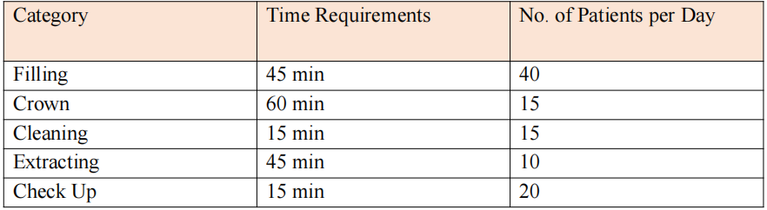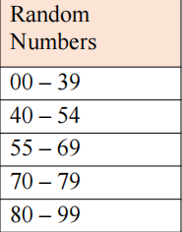
Simulate the dentist clinic using FCFS simulations for four hours and find out the average waiting time for the patients and the idleness of the doctor. Assume that all the patients show up at the clinic at exactly their scheduled time; let us consider the arrival time for the first patient as 8.00 AM. You may use the following random numbers for handling the above problem during the simulation [40, 82, 11, 34, 25, 66, 17, 79].

Now, the first citizens is arriving at exactly 8.00 AM. Each citizen's average serving time is 30 minutes. According to the problem, we have to simulate the situation for the next four hours, equal to 240 minutes. So, the counter will serve the citizens till 12.00 PM. The maximum number of
citizens can be allotted for the service is 8. Kindly see the below table carefully

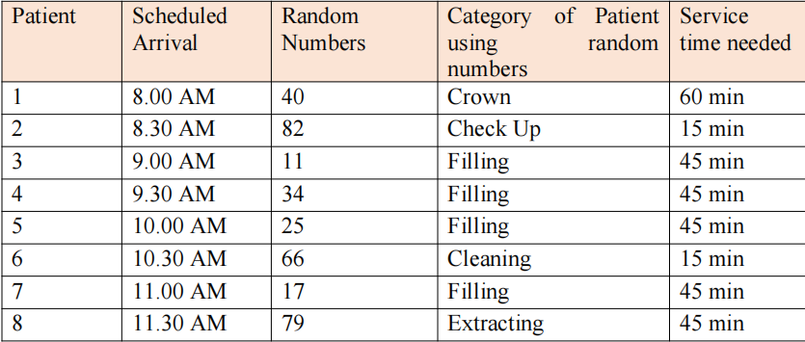

Solution

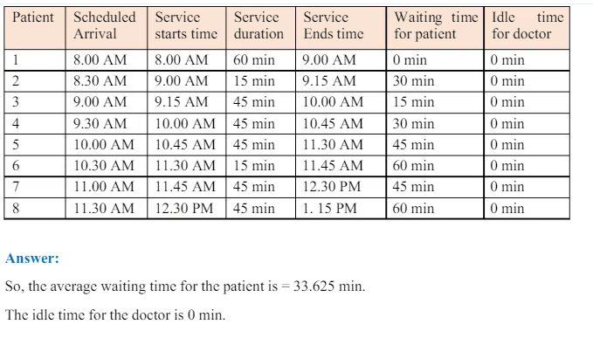

Average Service Time : (60+15+45+45+45+15+45+45)/8;

Turn Around Time = Service Ends-Scheduled Arrival

Average Turn Around time : (60+45+60+15+90+15+90+105)/8

Question-2

Create a thread pool using Pthread Library in C and use it to manage the following threads. Your program will run for 60 seconds and then stop on its own. Your threads will maintain a "stop" Boolean variable that begins at false. A stop() method will turn this true. While stop is false, your threads will continue their task, but at 60 seconds, your main thread will call stop() on each of the threads. Thread 0 - Your main thread. Runs the program and stops 60 seconds later. Thread 1 - Prints "Hello?" every 2 seconds. * Thread 2 - Prints "Goodbye!" every 4 seconds. * Thread 3 - Create a long variable and increment it by 1 every tenth of a second. Printing "Eureka #x!” at every 100th increment, where x is the current value of the variable. Thread 4 - Print prime numbers beginning with 2.sec only pthread library in C, Your main thread should tell the others to quit. They will just run forever otherwise.

Answer

#include <stdio.h>
#include <pthread.h>
#include <unistd.h>
#include <stdbool.h>

#define MAX_THREADS 5

volatile bool stop_flag = false; // Volatile to ensure visibility across threads

void *thread_hello(void *arg) {
while (!stop_flag) {
printf("Hello?\n");
sleep(2);
}
return NULL;
}

void *thread_goodbye(void *arg) {
while (!stop_flag) {
printf("Goodbye!\n");
sleep(4);
}
return NULL;
}

void *thread_eureka(void *arg) {
long count = 0;
while (!stop_flag) {
usleep(100000); // 1/10th of a second
count++;
if (count % 100 == 0) {
printf("Eureka #%ld!\n", count);
}
}
return NULL;
}

bool is_prime(int num) {
if (num <= 1) return false;
for (int i = 2; i * i <= num; i++) {
if (num % i == 0) return false;
}
return true;
}

void *thread_prime(void *arg) {
int num = 2;
while (!stop_flag) {
if (is_prime(num)) {
printf("%d\n", num);
}
num++;
sleep(1);
}
return NULL;
}

void stop() {
stop_flag = true;
}

int main() {

pthread_t threads[MAX_THREADS];

// Create threads
pthread_create(&threads[0], NULL, thread_hello, NULL);
pthread_create(&threads[1], NULL, thread_goodbye, NULL);
pthread_create(&threads[2], NULL, thread_eureka, NULL);
pthread_create(&threads[3], NULL, thread_prime, NULL);

// Main thread waits for 60 seconds
sleep(60);

// Stop all threads
stop();

// Join threads
for (int i = 0; i < MAX_THREADS; i++) {
pthread_join(threads[i], NULL);
}

return 0;
}

In this version, the stop_flag variable is declared as volatile to ensure visibility across threads. This ensures that changes made by one thread to the stop_flag variable are visible to other threads immediately.

1 OF 2

